**THERESE M. SCOTT, D.O.**

18475 S. Redland Rd.

Oregon City, OR 97045

Office # 503-558-8918

Fax # 971-600-9151

# NEW MVA INJURY REPORT

Name __________________________________ Date: _________________________

Date and time of the accident: _____________________________________________

Describe what happened in the accident:

_______________________________________________________________________

________________________________________________________________________

________________________________________________________________________

_____________________________________________________________________

You were the: [ ] driver [ ] passenger

If you were not the owner of the vehicle, who is the owner, and what is the relationship to you?_________________________________________________

Type of vehicle you were in?

[ ] Type__________________ [ ] Make________________[ ] Year_______

Your vehicle was an [ ] automatic [ ] clutch?

Were you wearing a seat belt and shoulder harness? [ ] Yes [ ] No

How fast were you moving?

The other vehicle(s:

[ ] Type__________________ [ ] Make________________[ ] Year_______

How fast was the other vehicle(s) moving?_________________

Was a police report made? [ ] Yes [ ] No

Were the police at the scene? [ ] Yes [ ] No

Was anyone cited for the accident? [ ] Yes [ ] No

If so, who was it issued to?____________________________________________

Who was at fault?_________________________________________________________

Was the accident reported to your insurance company? [ ] Yes [ ] No

Was the accident reported to the other insurance company? [ ] Yes [ ] No

What were the road conditions?______________________________________________

What was the position of your body at the time of impact?

Hands?___________________________________________________________

Left foot?_________________________________________________________

Right foot?________________________________________________________

Eyes?____________________________________________________________

Head?____________________________________________________________

Do you remember striking any part of your body on any part of the vehicle? [ ]Yes [ ]No

What part of your body?

Did you hit your head on the headrest or anything else? [ ] Yes [ ] No

Did you loose consciousness? [ ] Yes [ ] No

Were you able to think clearly after the accident? [ ] Yes [ ] No

Were you able to walk away from the vehicle? [ ] Yes [ ] No

If not, were you taken by ambulance to a hospital? [ ] Yes [ ] No

If so, which hospital?________________________________________________

What tests were done at the hospital?____________________________________

Were you given any prescriptions? (list names and strengths)

Have you been able to go to work since the accident? [ ] Yes [ ] No

If so, have you been able to complete all your regular duties at work?[ ] Yes [ ] No

As a result of the accident have you been unable to perform any particular household duties?

Describe your symptoms at the time of the impact:

Describe your symptoms currently:

Describe your medical care for your condition:

On the diagrams below, shade the area(s) where you feel pain. “X” the areas that hurt the most.

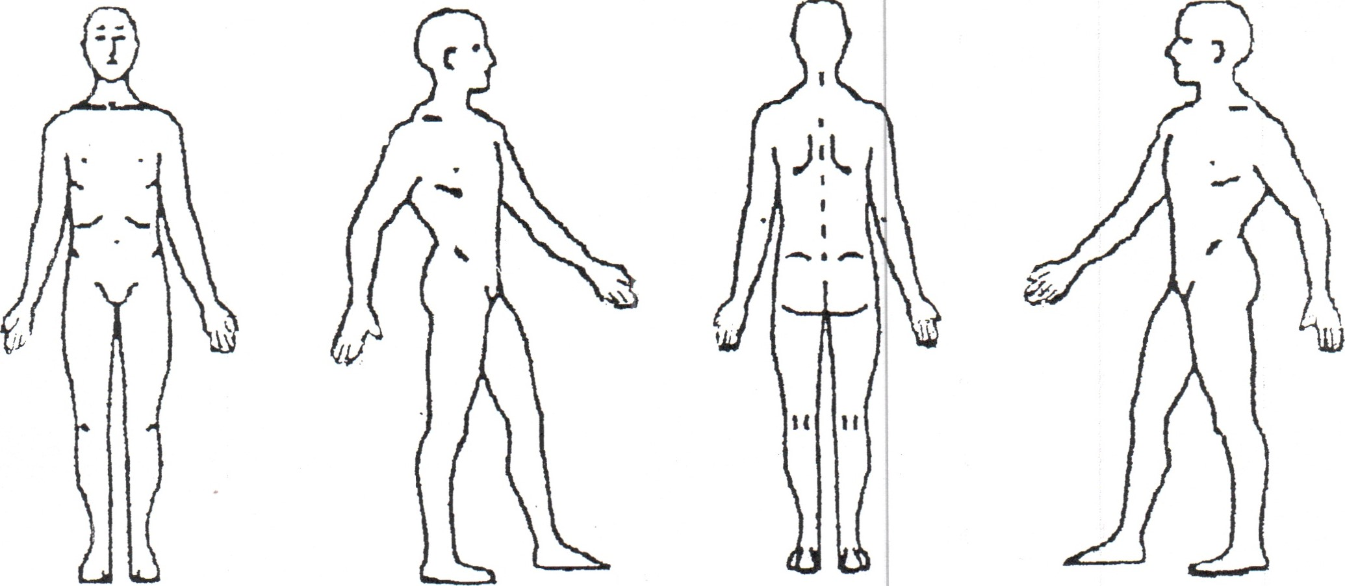

Circle the words that describe your pain:

|  |  |  |  |  |
| --- | --- | --- | --- | --- |
| Aching | Sharp | Penetrating |  | Throbbing |
| Tender | Nagging | Shooting |  | Burning |
| Numb | Stabbing | Exhausting |  | Miserable |
| Gnawing | Tiring | Unbearable |  | Intermittent |

Continuous

What makes your pain better?_______________________________________________

What makes your pain worse?_______________________________________________

Have you noticed any of the following symptoms? CIRCLE ANY THAT APPLY

|  |  |  |  |
| --- | --- | --- | --- |
| Headache |  | Neck pain | Neck stiffness |
| Jaw pain |  | Clicking in jaw | Ringing in ears |
| Blurred or double vision |  | Sleeping difficulties | Mid back pain |
| Low back pain |  | Nervousness | Tension |
| Iirritability |  | Chest pain | Head seems heavy |
| Pins/needles in arms |  | Pins/needles in legs | Nausea |
| Shoulder pain |  | Shortness of breath | Fatigue |
| Dizziness |  | Constipation | Wrist or elbow pain |
| Depression |  | Light bothering eyes | Loss of memory |
| Buzzing in ears |  | Loss of balance | Fainting |
| Loss of smell |  | Loss of taste | Diarrhea |
| Feet or hands cold or hot |  | Cold sweats | Fever |
| Numbness/fingers or toes |  | Knee or ankle pain | Stomach upset |
| Fear of driving or sitting in a car Any other symptoms? | |  |  |

**Therese M. Scott, D.O.**

**18475 S. Redland Rd.**

**Oregon City, OR 97045**



**503-558-8918**

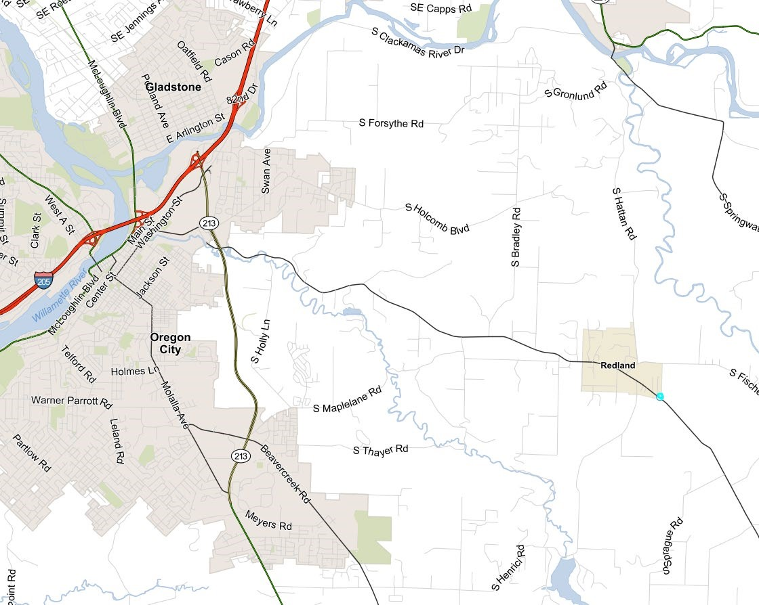

From 205 take exit 10 to Oregon City/Molalla. At the second light turn right onto Redland Rd. and continue for approximately 6 miles. You will pass a fire station and Catholic church. The driveway is just past Scott Lane on the left side. Look for a yellow house and a yard spinner at the driveway entrance. The office door is on the left side of the house.

**Therese M. Scott, D.O.**

**18475 S. Redland Rd.**

**Oregon City, OR 97045 503-558-8918**

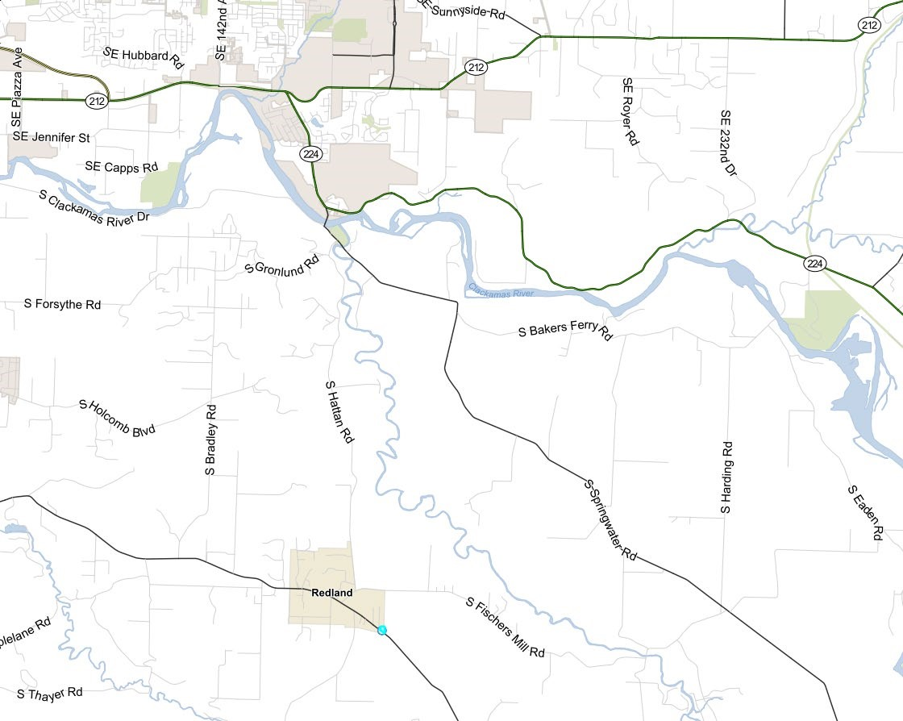

From Gresham, Sandy, Troutdale, etc. you will take Hwy 212 west left to Hwy 224. Follow the signs to Carver. At the second light you will turn right and go over the bridge, continue left to Hatton Rd. which is on your right. Stay on Hatton Rd. until it T’s at Fischer Mill Rd. Turn right. At the stop sign turn left on Redland Rd. The driveway is .5 miles from this point. You will pass a fire station and Catholic church. The driveway is just past Scott Lane on the left side. Look for a yellow house and a yard spinner at the driveway entrance. The office door is on the left side of the house.

**Therese M. Scott, D.O.**

**Patient Medical History Form**

Name:_______________________________ Date:_________________________

Current Problems/Complaints: (Please list your symptoms/problems)

Have you had x-rays, CT scans, MRI scans? ________ If yes, dates/place taken and results if known:

What makes your condition better and what makes it worse?

What are you not able to do that you could do before your injury/condition?

List allergies to medications:

List current medications, including dose and strength:

List current herbal preparations, vitamins, and homeopathics:

Previous surgeries, dates and procedures done:

Do you wear: [ ] Glasses [ ] Contact Lenses [ ] reading only (check)

Have you had eye surgery? If yes, Date:_______________,

Side: [ ]Left [ ] Right [ ] Lasik [ ] Radial Keratotomy

Describe any other hospitalization:

*********************** PLEASE TURN OVER **************************

Mac/Desktop/MasterRegistrationandMasterForms/PatientMedicalHistory

Medical Problems, (example: high blood pressure, diabetes, etc.)

Date of diagnosis: Problem:

_______________________ ______________________

_______________________ ______________________

_______________________ ______________________

Are you: [ ] married [ ] single [ ] with significant other (check)

Do you, or have you ever smoked, chewed tobacco, or used electronic cigarettes? (describe amount)

Do you use alcohol, and if so how often and how much?

Describe your occupation:

Describe your children’s names, age, and health:

Age of mother (or at time of death) and any health problems:

Age of father (or at time of death) and any health problems:

Any medical illness that runs in your family (cancer, diabetes, etc.)?

Current weight:______________ Any gain or loss in the last year?[ ] Yes [ ] No

Dental problems: [ ] Yes [ ] No If yes, explain_____________________________

Orthodontia issues: If yes, explain__________________________________________ Herbst Appliance [ ] Palatal Expander [ ] Age: From______ To_________

*Female patients: Date of last menstrual period _______________________________*

*Number of Pregnancies:_____________ Any problems with delivery? [ ] Yes [ ] No*

Were **you** born from a C-section or vaginal birth? ______________________________

Describe any previous car accidents and injuries: (include dates)

Have you ever had: [ ] “the wind knocked out of you” [ ] blackout or concussion If so, please describe:

**FINANCIAL POLICIES**

**PLEASE READ CAREFULLY**

**Patient Responsibility:**

I understand and agree that health and accident insurance policies are an arrangement between the insurance carrier and myself. Furthermore, I understand that Therese M. Scott, D.O. and staff will prepare any necessary reports and forms to assist in making collections from the insurance company, and that any amount authorized to be paid directly to Therese M. Scott, D.O., will be credited to my account on receipt. By signing below I authorize my insurance company to pay and hereby assign directly to Therese M. Scott, D.O. all owed benefits. However, I clearly understand and agree that all services rendered to me are charged directly to me and that I am personally responsible for payment for such services.

It is further understood and agreed that any and all costs incurred by Therese M. Scott, D.O., in collecting on a past due account, including collection costs and attorney fees, both at trial and on appeal, shall be payable by myself (the patient, or patient's guardian, or parent). Interest will be charged on balances over 60 days, 18% per annum.

**Insurance Information**:

**Medicare**: Therese M. Scott, D.O., does not bill Medicare for any services performed. Dr. Scott has opted out of Medicare and cannot except any form of Medicare, including Advantage plans. If, while under Dr. Scott's care, I become eligible for Medicare, I will immediately inform the front desk regarding this.

**Workers Compensation**: In order to file a Workers' Compensation claim, the name of your insurance carrier, the date of injury, and claim number, if available, is needed. I will notify the front desk if the visit is due to an injury covered by Workers’ Compensation.

**Private Insurance:** For the convenience of our patients, we will bill private insurance with assignment of payment to Therese M. Scott, D.O.If you have a co-payment plan, your co-payment is due at the time of service. Other balances on the account will be billed to you when we receive payment from the insurance company. We do not bill secondary insurance companies.

**Motor Vehicle Insurance**: In order to bill for a motor vehicle accident, the name of your insurance company, date of accident, and claim number is needed. The office will bill your vehicle insurance directly. If your insurance company does not pay for the services rendered it is your responsibility to pay for the services and receive reimbursement from your motor vehicle insurance.

**Same Day Payments:** A reduction in fees is available to patients paying at the time of the visit with cash or check. If other arrangements are made for payment or a card is used, cash reduction does not apply. The office does accept Cash, Check, and Credit/Debit cards.

**Cancellation Policy:** The office of Therese M. Scott, D.O. requires 48 hours notice if you must cancel your appointment. Otherwise, you will be charged a fee of $100.00 for an established patient and $150.00 for a new patient for a non-cancelled visit, which must be paid in advance of a future appointment. Insurance companies do NOT reimburse such charges. Please note that I have allotted a 45 to 60 minute slot that is dedicated entirely to you, and I appreciate your consideration of my schedule.

I have read and understand the above information.

_______________________________________________________________________ ______________________________

Name (printed) Driver’s License Number and State

____________________________________________________________________ ____________________________

Patient signature (or guardian if patient is a minor under age 15, and relationship) Date

**THERESE M. SCOTT, D.O.**

**Please Print**

|  |  |
| --- | --- |
| Name: ________________________________________  Last First Initial | Date:_________________________ |
| Address: ______________________________________ | Birth date: _________Age:_______ |
| ______________________________________________ | Home # (___)__________________ |
| Emergency Contact:_____________________________ | Work # (___)__________________ |
| Phone:________________________ | Cell # (___)__________________ |
| Employer name: _______________________________ | **(Check “preferred contact #”)** |
| Occupation:__________________________ | Referred by: __________________ |
|  | (Dr., friend, yellow pages, Ins co., etc.) |

* ⬆⬆⬆⬆ **IF THIS IS FOR A MOTOR VEHICLE ACCIDENT** ⬆⬆⬆⬆⬆

***If Not: Please turn over for private health insurance information.***

|  |  |
| --- | --- |
| ***Your*** MVA Ins. Co.:____________________________ | Telephone# ___________________ |
| Address:______________________________________ | Claim#________________________ |
| ______________________________________________ | Policy #_______________________ |
| Policy is in who’s name?________________________ | Relationship to patient:_________ |
| Policyholder’s birth date:________________ | Date of Accident:_______________ |

Have you seen anyone for these injuries? [ ] Yes [ ] No If “Yes” please state where and

when:_________________________________________________________________________

* ⬆⬆⬆⬆ **OTHER PARTY’S MVA INSURANCE** ⬆⬆⬆⬆⬆

Ins. Co.:_____________________________________ Telephone #:_________________

Address:______________________________________ Claim number #:_______________

**PLEASE TURN OVER**

* ⬆⬆⬆⬆ **IF WORKING WITH AN ATTORNEY** ⬆⬆⬆⬆⬆

Name of Attorney:_____________________________________________________________

Address:______________________________________________________________________

Telephone:___________________________________________________________________

* ⬆⬆⬆⬆ **PRIMARY HEALTH INSURANCE** ⬆⬆⬆⬆⬆

Insurance Co: ________________________________ Phone # _____________________

Group#__________________ I.D. or Policy #:______________________________

Policy in whose name? ________________________ Relationship to pt: ____________

Policyholder's birth date: _______________

⋅ ⋅ ⋅ ⋅ ⋅ ⋅ ⋅ ⋅ ⋅ ⋅ ⋅ ⋅ ⋅ ⋅ ⋅ ⋅ ⋅ ⋅ ⋅ ⋅ ⋅ ⋅ ⋅ ⋅ ⋅ ⋅ ⋅ ⋅ ⋅ ⋅ ⋅ ⋅ ⋅ ⋅ ⋅ ⋅ ⋅ ⋅ ⋅ ⋅ ⋅ ⋅ ⋅ ⋅ ⋅ ⋅ ⋅ ⋅ ⋅ ⋅ ⋅ ⋅ ⋅ ⋅ ⋅ ⋅

Primary Doctor's name: _______________________ Phone #______________________

Address: _______________________________________________________________________

In consideration of medical services rendered by Therese M. Scott, D.O., I guaranty payment of all charges incurred. I understand that I may not receive total reimbursement from my

insurance company. I authorize payment from insurance company to Therese M. Scott, D.O.

I authorize the companies listed herein, or their representative, and any and all information or copies with respect to any illness, prescription, or treatment. This information may be

used only for the verification of claims for medical treatment and may not be re-released to

anyone other than specified. If I carry group insurance through my employer, I understand my employer may be informed of my diagnosis. This authorization may be revoked by the undersigned, following written notice received by the provider, to take place at the time received by provider.

Print Name_____________________________________________ Date:________________

Signature________________________________________________________________________

(If minor under age 15, signature of legal guardian)

**Therese M. Scott D.O. 18475 S. Redland Rd.**

**Oregon City, OR**

**503-558-8918**

**Fax 971-600-9151**

# Cancellation Policy

Our office sees patients by appointment only. If you are unable to keep your appointment, please notify us as early as possible so that we are able to offer the time to another patient. Your account may be charged a cancellation fee if you cancel your appointment less than 48 hours prior, or fail to show up for your appointment. You will be charged a fee of $100.00 for established patients and $150.00 for new patients for a non-cancelled visit, which must be paid in advance of a future appointment. We do make exceptions for emergency’s or in climate weather. Insurance companies do NOT reimburse such charges. Please note that I have allotted a 45 to 60 minute slot that is dedicated entirely to you, and I appreciate your consideration of my schedule.

# Fragrance Free Office

A no Fragrance Policy is implemented in our office. Many of the patients, as well as Dr. Scott, are sensitive to certain scents such as perfumes, lotions, body sprays, oils, hair products, and cigarette smoke. We ask that you and anyone who comes with you be thoughtful of the people around you and refrain from wearing any fragrant products to our office.

By signing below you agree to these policies.

_________________________________________________ ________________

Patient Name (Print) Date

____________________________________________________

Patient Signature

# Authorization to Release Medical Information

Patient Name:____________________________________________________________

Address:________________________________________________________________

Date of Birth:______________________ Phone:________________________

I, or my authorized representative, request that the health information regarding my care and treatment be released to the below named Provider. In accordance with the privacy rule of the Health Insurance Portability and Accountability Act of 1996 (HIPAA), I understand that:

1. This authorization may include information in reference to: drug and/or alcohol abuse, psychiatric care, sexually transmitted disease, Hepatitis testing, genetic testing, and/or other sensitive information, I agree to its release ___ YES ___ NO Initials ____
2. My medical or billing record my contain information in reference to HIV/AIDS testing and/or treatment, I agree to its release. ___ YES ___NO Initials ________
3. I have the right to revoke this authorization by submitting a notice in writing to the office of Therese M. Scott D.O. Unless revoked, This authorization will expire in 180 days or on the following date: ________________________________.
4. Information disclosed by this authorization may be subject to re-disclosure by the recipient and will no longer be protected by federal or state law. The facility, its employees, and physicians are hereby released from any legal responsibility or liability for disclosure of the above information to the extent indicated and authorized herein.

I hereby request:

___________________________________________ Phone or Fax________________

____________________________________________ Phone or Fax________________

____________________________________________ Phone or Fax________________ Information to be Released:

ο Report and Films Date________________

ο Medical Record Date from_________________ to _________________ ο Emergency Report Date________________

ο Other ______________________________________________________________

Signature:__________________________________________ Date:_______________

Please send this information to:

Therese M. Scott D.O.

18475 S. Redland Rd.

Oregon City, OR 97045

Office (503) 558-8918

Fax (971) 600-9151

admin@drscottosteo.com

**THERESE M. SCOTT, D.O.**

18475 S. Redland Rd.

Oregon City, OR 97045

Office # 503-558-8918

Fax # 971-600-9151

## CONSENT FOR OSTEOPATHIC TREATMENT

I understand that, in consenting to undergo Osteopathic Manipulative Treatment, I recognize that any of the following could occur usually up to 72 hours post treatment:

1. I could feel sore, experience more pain, headaches, or unusual fatigue for a few days following a treatment.

1. It is possible for complaints to worsen before getting better, with the possibility that discomfort could develop in new areas. Specifically, headaches my worsen before they get better.

1. My body may change through these treatments, seeking its own new balance point.

The intent of Osteopathic Treatment is to improve the functioning of the musculoskeletal system, and this often leads to an improved sense of well-being, but no guarantees are given about resolution of specific complaints.

Name:___________________________________ Date: ________________ (Printed)

Signature:_______________________________________________________________ (Guardian if patient is a minor under 15 years, and relationship)